Programming Concepts - Tutorial 8
HIT265 – C Programming
Question 1
Apply Kruskal’s algorithm to each of the graphs in Figure 1. Don’t forget to show the tree at each stage in your answer. In the graphs where no edge weights are given, assume an edge weight of 1 for each unlabeled edge. Remember to use the alphabetic/numeric convention when creating your list of edges ordered by weight.
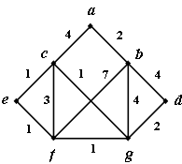
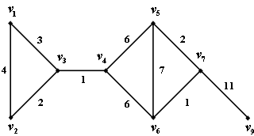
(a)
(b)

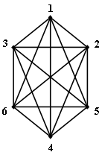
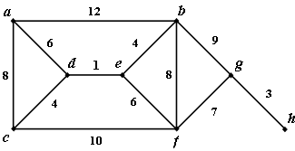
(c)
(d)

Figure 1
Question 2
- Calculate the total weight of each tree produced in question 1.
- Is it possible to create different (non-isomorphic) MWSTs using Kruskal’s algorithm. Explain your answer.
- If Prim’s algorithm and Kruskal’s algorithm are applied to the same graph, will they always produce the same MWST? Why/why not?
Question 3
Explain how Kruskal’s MWST algorithm can be modified to produce a maximum-weight spanning tree.

